SOEN 331 – Assignment 3

Sam Assaf – 6150748  
Jessica Falco – 6597882

We decided to add a top level state called **active** in order to handle the universal kill transition and added it to the specification.

# Top-Level

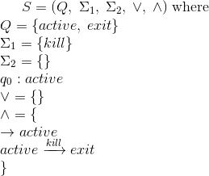

# Overall EFSM

gif (12)

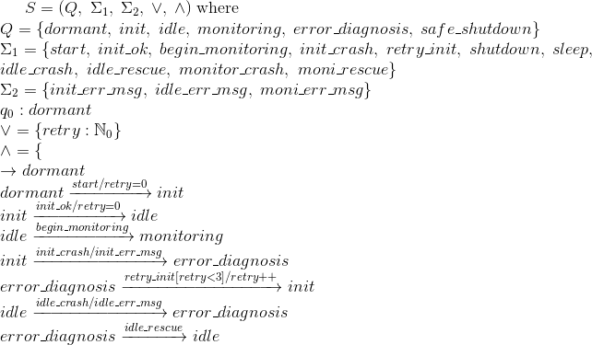

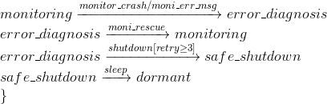

# Refine init

gif (12)

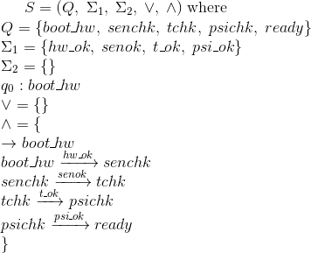

# Refine monitoring

gif (12)

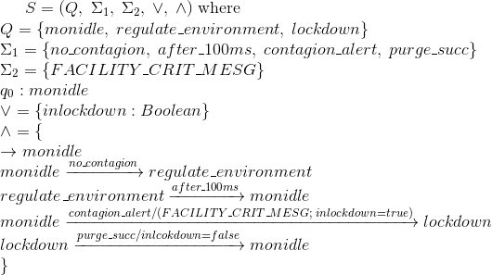

# Refine lockdown

gif (12)

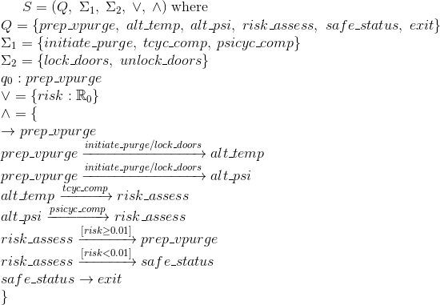

# Refine error diagnosis

gif (12)

